**EXPIREMENT 9**

**AIM**

Compose Electricity bill from user input based on a given tariff using PHP.

**PROGRAM CODE**

<html>

<head>

<title>ELECTRICITY BILL</title>

</head>

<?php

$result_str = $result = '';

if (isset($_POST['unit-submit'])) {

$units = $_POST['units'];

if (!empty($units)) {

$result = calculate_bill($units);

$result_str = 'Total amount of ' . $units . ' - ' . $result;

}

}

function calculate_bill($units) {

$unit_cost_first = 3.50;

$unit_cost_second = 4.00;

$unit_cost_third = 5.20;

$unit_cost_fourth = 6.50;

if($units <= 50) {

$bill = $units * $unit_cost_first;

}

else if($units > 50 && $units <= 100) {

$temp = 50 * $unit_cost_first;

$remaining_units = $units - 50;

$bill = $temp + ($remaining_units * $unit_cost_second);

}

else if($units > 100 && $units <= 200) {

$temp = (50 * 3.5) + (100 * $unit_cost_second);

$remaining_units = $units - 150;

$bill = $temp + ($remaining_units * $unit_cost_third);

}

else {

$temp = (50 * 3.5) + (100 * $unit_cost_second) + (100 *

$unit_cost_third);

$remaining_units = $units - 250;

$bill = $temp + ($remaining_units * $unit_cost_fourth);

}

return number_format((float)$bill, 2, '.', '');

}

?>

<body>

<h1>ELECTRICITY BILL</h1>

<form method="post" action="" id="elect">

<input type="number" name="units" id="units"

placeholder="place enter the no. of units">

<input type="submit" name="unit-submit" id="unit-submit"

value="submit">

</form>

<?php echo '<br />' . $result_str; ?>

</body>

</html>

**OUTPUT**



**EXPIREMENT 10**

**AIM**

Build a PHP code to store name of students in an array and display it using print_r function. Sort and Display the same using asort & arsort functions.

**PROGRAM CODE**

<html>

<head>

<title>Program 10</title>

</head>

<body>

<h2>Student Names.</h2>

<?php

if(!isset($_POST['submit']))

{

?>

<form name="billform" method="POST" action="storestud.php">

<strong>Enter Name 1: </strong><input type="text"

name="name1" required>

<br><br>

<strong>Enter Name 2: </strong><input type="text"

name="name2" required>

<br><br>

<strong>Enter Name 3: </strong><input type="text"

name="name3" required>

<br><br>

<strong>Enter Name 4: </strong><input type="text"

name="name4" required>

<br><br>

<strong>Enter Name 5: </strong><input type="text"

name="name5" required>

<br><br>

<input type="submit" name="submit" value="Submit">

<input type="reset" name="reset" value="Reset">

</form>

<?php

}

else

{

$names[0]=$_POST['name1'];

$names[1]=$_POST['name2'];

$names[2]=$_POST['name3'];

$names[3]=$_POST['name4'];

$names[4]=$_POST['name5'];

?>

<strong>Names: </strong>

<?php

print_r($names);

?>

<br><br>

<strong>Names in ascending order: </strong>

<?php

asort($names);

print_r($names);

?>

<br><br>

<strong>Names in descending order: </strong>

<?php

arsort($names);

print_r($names);

}

?>

</body>

</html>

**OUTPUT**

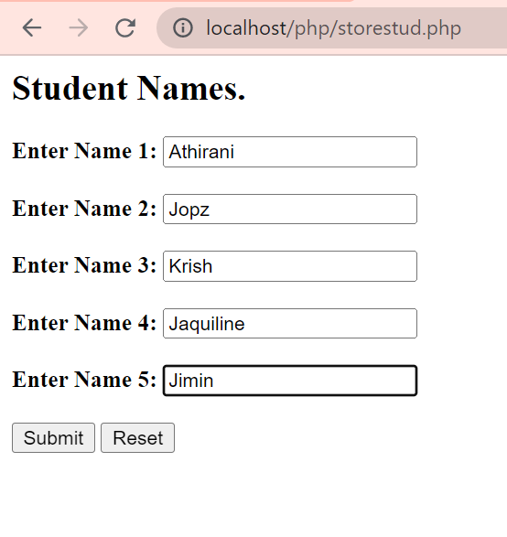

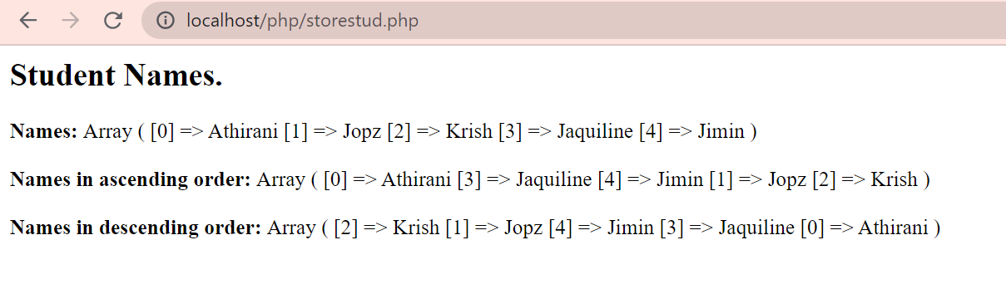

**EXPIREMENT 11**

**AIM**

Build a PHP code to store name of Indian Cricket players in an array and display the same in HTML table.

**PROGRAM CODE**

**Crckt.html**

<html>

<head>

<title>Cricket players</title>

</head>

<body>

<form method="POST" action="crc.php">

<table>

<tr>

<h2>Names of Cricket players</h2></tr>

<tr>

<td>Enter Name1 : <input type="text" name="nm1"></td><br></tr>

<td>Enter Name2 : <input type="text" name="nm2"></td><br></tr>

<td>Enter Name3 : <input type="text" name="nm3"></td><br></tr>

<td>Enter Name4 : <input type="text" name="nm4"></td><br></tr>

<td>Enter Name5 : <input type="text" name="nm5"></td><br></tr>

<td><input type="submit" style="background-color:red;"></td>

</table>

</form>

</body>

</html>

**Crc.php**

<?php

$p1=$_REQUEST["nm1"];

$p2=$_REQUEST["nm2"];

$p3=$_REQUEST["nm3"];

$p4=$_REQUEST["nm4"];

$p5=$_REQUEST["nm5"];

$arr=array("$p1","$p2","$p3","$p4","$p5");

echo"The names of 5 indian cricket players are as follows<br><br>";

echo"<table>

<tr>

<th>Player 1</th>

<td>$p1</td>

</tr>

<tr>

<th>Player 2</th>

<td>$p2</td>

</tr>

<tr>

<th>Player 3</th>

<td>$p3</td>

</tr>

<tr>

<th>Player 4</th>

<td>$p4</td>

</tr>

<tr>

<th>Player 5</th>

<td>$p5</td>

</tr>

</table>";

**OUTPUT**

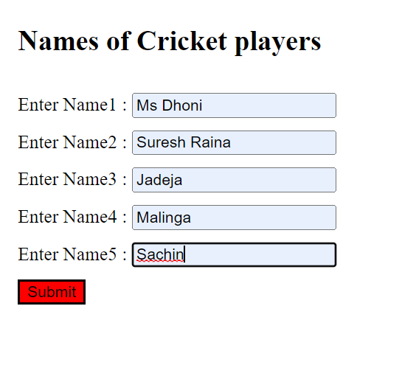

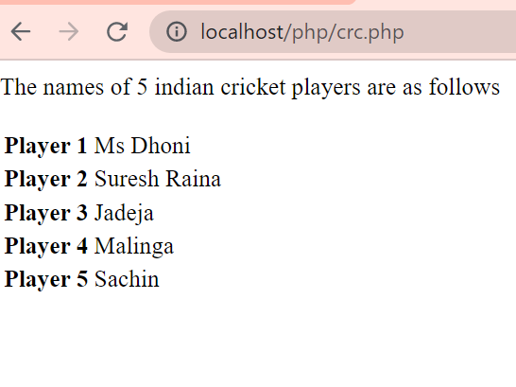

**EXPIREMENT 12**

**AIM**

Outline a registration form using PHP and do necessary validations.

**PROGRAM CODE**

**1.php**

<?php

$name=$_POST['name'];

$num=$_POST['phnum'];

$email=$_POST['email'];

$pass=$_POST['pass'];

$cpass=$_POST['cpass'];

if($name==NULL)

        {

          echo "<script>alert('please enter your name');window.history.back();</script>";

          return false;

        }

if($email==NULL)

        {

          echo "<script>alert('please enter your EmailId');window.history.back();</script>";

          return false;

        }

if (!filter_var($email, FILTER_VALIDATE_EMAIL))

        {

         echo "<script>alert('please enter valid EmailId');window.history.back();</script>";

         return false;

        }

if($num==NULL)

        {

          echo "<script>alert('please enter your Number');window.history.back();</script>";

          return false;

        }

if(!ctype_digit($num))

        {

          echo "<script>alert('please enter your Number with numeric value');window.history.back();</script>";

          return false;

        }

if(strlen($num)!=10)

        {

          echo "<script>alert('please enter your Number with 10 digit');window.history.back();</script>";

          return false;

        }

if($pass==NULL)

        {

          echo "<script>alert('please enter your Password');window.history.back();</script>";

          return false;

        }

if(strlen($pass)<8)

        {

          echo "<script>alert('password must be 8 characters');window.history.back();</script>";

          return false;

        }

if($cpass==NULL)

        {

          echo "<script>alert('please enter your password again');window.history.back();</script>";

          return false;

        }

if($pass!=$cpass)

        {

          echo "<script>alert('Password do not match');window.history.back();</script>";

          return false;

        }

else

  {

    echo "<script>alert('submitted successfully');</script>";

    echo "<h4>we are validating your request..Thank you for your patience</h4>";

    return false;

  }

?>

**2.php**

<!DOCTYPE html>

<html lang="en">

<head>

    <meta charset="UTF-8">

    <meta name="viewport" content="width=device-width, initial-scale=1.0">

    <meta http-equiv="X-UA-Compatible" content="ie=edge">

    <title>home page</title>

    <script src="js/jquery.js"></script>

    <link rel="stylesheet" href="style.css">

</head>

<body>

   <div class="main">

        <div class="inner">

            <div class="welcome">

                Registration Form

            </div>

            <div class="registration_options">

                <form action="1.php" method="post">

                    <table class="table">

                        <tr>

                            <td>

                                Enter your name :

                            </td>

                            <td>

                                <input type="text" name="name" id="">

                            </td>

                        </tr>

                        <tr>

                            <td>

                                Enter your email id :

                            </td>

                            <td>

                                <input type="email" name="email" id="">

                            </td>

                        </tr>

                        <tr>

                            <td>

                                Enter your Number :

                            </td>

                            <td>

                                <input type="text" name="phnum" id="">

                            </td>

                        </tr>

                        <tr>

                            <td>

                                Enter your password :

                            </td>

                            <td>

                                <input type="password" name="pass" id="">

                            </td>

                        </tr>

                        <tr>

                            <td>

                                Confirm your password :

                            </td>

                            <td>

                                <input type="password" name="cpass" id="">

                            </td>

                        </tr>

                    </table>

                    <div class="btn">

                        <input type="submit" name="submit" value="Submit" id="save">

                    </div>

                </form>

            </div>

        </div>

    </div>

</body>

</html>

**Style.css**

.main{

    height: auto;

    width: 100%;

}

.inner{

    width: 80%;

    height: 580px;

    border: 1px solid white;

    box-shadow: 0 0 10px rgb(84, 82, 82);

    margin: 30px auto 30px auto;

}

.welcome{

    text-align: center;

    padding: 20px;

    font-size: 40px;

    font-family: Cambria, Cochin, Georgia, Times, 'Times New Roman', serif;

    border-bottom: 1px solid rgb(250, 138, 138);

    background-color: rgb(245, 91, 91);

    color: white;

}

.table{

    border: none;

    text-align: center;

    width: 100%;

    margin: auto;

    margin-top: 100px;

}

.table tr{

    text-align: center;

}

.table td{

    font-size: 22px;

    font-family: cursive;

    line-height: 2em;

    text-align: center;

}

.table td input{

    padding: 2px 55px;

    text-align: center;

    border: none;

    width: 200px;

    border-bottom: 2px solid black;

}

.btn{

    text-align: center;

}

#save{

    font-size: 25px;

    background-color: rgb(82, 51, 239);

    color: white;

    padding: 5px 35px 5px 35px ;

    border: none;

    margin-top: 60px;

}

**OUTPUT**

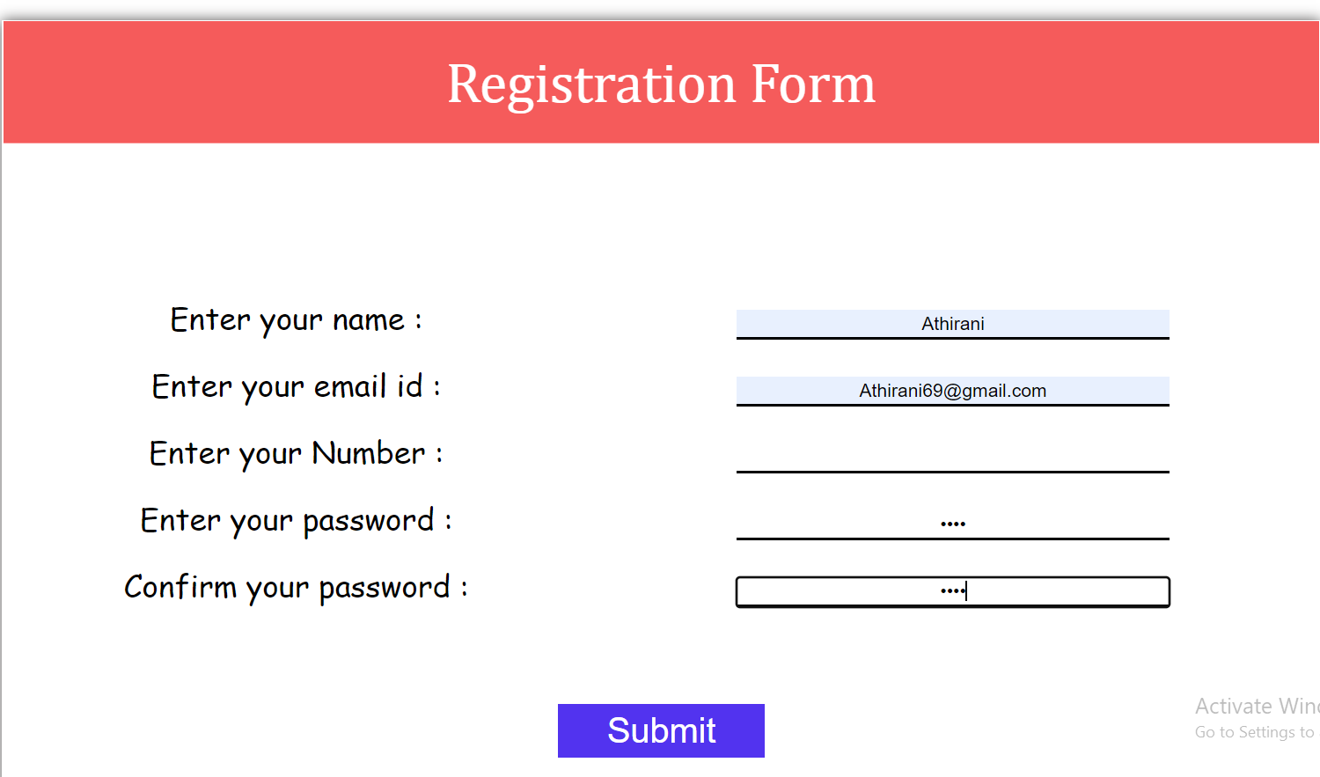

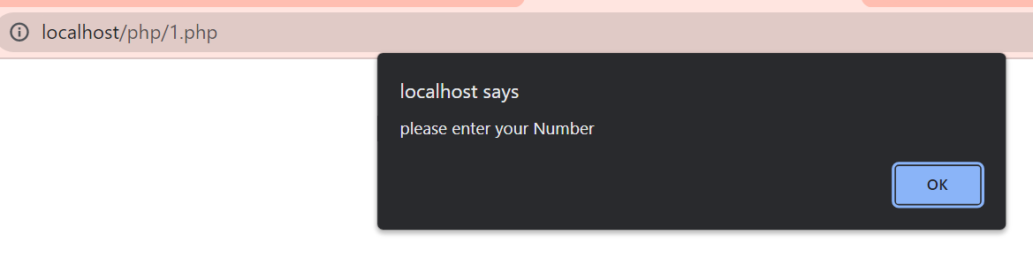

**EXPIREMENT 13**

**AIM**

Develop a PHP program to connect to a database and add data to the employee table and retrieve data from the table and show the retrieved details in a neat format.

**PROGRAM CODE**

**Employee.html**

<html>

<head>

<title>employee details</title>

</head>

<body>

<form method="POST" action="form.php">

<table cellspacing="9" cellspacing="8">

<td colspan="2">

<h1 align="center"> ADD EMPLOYEE </h1>

<hr>

</td>

<tr>

<td>Employee id:<input type="" name="id"></td>

</tr>

<tr>

<td>Employee name:<input type="text" name="nm"></td>

</tr>

<tr>

<td>Employee Age:<input type="number" name="no"></td>

</tr>

<tr>

<td>Department:<input type="text" name="dep"></td>

</tr>

<tr>

<td><input type="submit" value="submit": style="background-color:rgb(16, 221, 64);">

<input type="reset" value="reset": style="background-color:rgb(138, 231, 135);"></td>

</tr>

</table>

</form>

</body>

</html>

**form.php**

<?php

$nm=$_POST['nm'];

$no=$_POST['no'];

$dep=$_POST['dep'];

$id=rand(1000,9999);

$con= new mysqli("lo

calhost","fisat","fisat","fisatdb");

if($con===false)

{

echo "failed to connect";

}

else

{ echo "connect";

}

$sql = "INSERT INTO employee

(emp_id,emp_name,emp_age,emp_dep) VALUES ('$id','$nm','$no','$dep')";

if ($con->query($sql) === true)

{

$sql1 = "SELECT emp_id,emp_name,emp_age,emp_dep FROM employee";

if ($result=$con->query($sql1))

{

if (($result->num_rows)>0)

{

echo "<h2>Employee Details.</h2>";

echo "<table border='1'>";

echo "<tr>";

echo "<th width='100'>Employee ID</th>"; echo "<th width='100'>Name</th>";

echo "<th width='100'>Age</th>";

echo "<th width='100'>Department</th>";

echo "</tr>";

while($row = $result->fetch_array())

{

echo "<tr>";

echo "<td>".$row[0]."</td>";

echo "<td>".$row[1]."</td>";

echo "<td>".$row[2]."</td>";

echo "<td>".$row[3]."</td>";

echo "</tr>";

}

echo "</table>";

$result->close();

}

}

else

{

echo "ERROR: Could not execute query: $sql1. " . $con- >error;

}

}

else

{

echo "ERROR: Could not execute query: $sql. " . $con- >error;

}

$con->close();

?>

**OUTPUT**

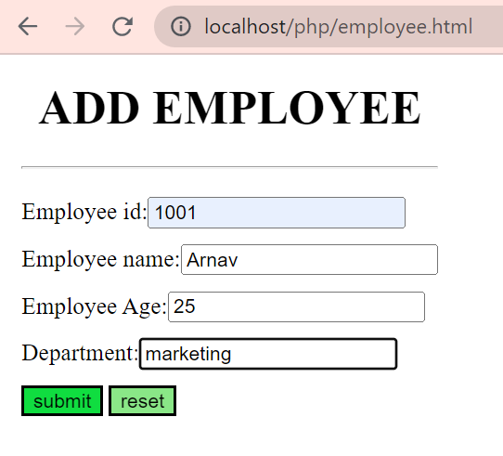



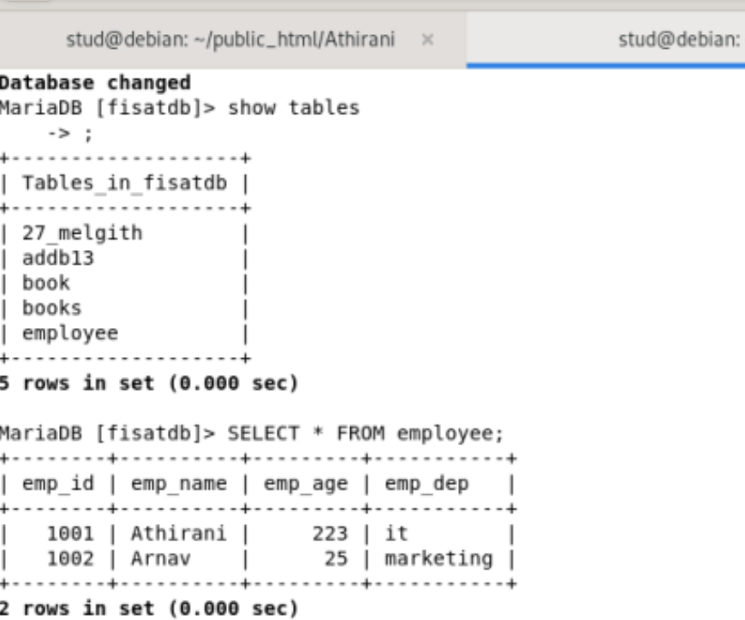

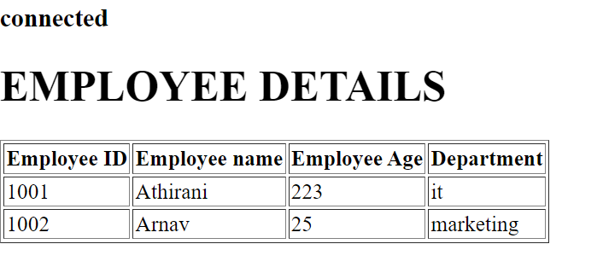

**EXPIREMENT 14**

**AIM**

Using PHP and MySQL, develop a program to accept book information viz. Accession number, title, authors, edition and publisher from a web page and store the information in a database and to search for a book with the title specified by the user and to display the search results with proper headings.

**PROGRAM CODE**

**Buklnk.html**

<html>

<head>

<title>books</title>

</head>

<body align="center">

<h1 align="center">BOOK INFORMATIONS </h1>

<hr>

<a href="dbbuk.html">BOOK DETAILS</a><br>

<a href="search.html">BOOKS TO SEARCH</a>

</body>

</html>

**dbbuk.html**

<html>

<head>

<title>employee details</title>

</head>

<body>

<form method="POST" action="buk.php">

<table cellspacing="9" cellspacing="8" align="center">

<td colspan="2">

<h1 align="center"> BOOK DETAILS </h1>

<hr>

</td>

<tr>

<td>Accession no :<input type="number" name="id"></td>

</tr>

<tr>

<td>Title    :   <input type="text" name="tit"></td> </tr>

<tr>

<td>Author   : <input type="text" name="aut"></td> </tr>

<tr>

<td>Edition  : <input type="text" name="edi"></td> </tr>

<tr>

<td>Publisher  : <input type="text" name="pub"></td> </tr>

<tr>

<td><input type="submit" value="submit":></td>

<td><input type="reset" value="reset":></td>

</tr>

</table>

</form>

</body>

</html>

**buk.php**

<?php

$tit=$_POST['tit'];

$aut=$_POST['aut'];

$edi=$_POST['edi'];

$pub=$_POST['pub'];

$id=$_POST['id'];

$con= new mysqli("localhost","fisat","fisat","fisatdb");

if($con===false)

{

echo "failed to connect";

}

else

{ echo "connect";

}

$sql = "INSERT INTO Book

(id,title,author,edition,publisher) VALUES ('$id','$tit','$aut','$edi','$pub')";

if ($con->query($sql) === true) {

echo 'New row added.';

} else {

echo "ERROR: Could not execute query: $sql. " . $con->error;

}

$con->close();

?>

**search.html**

<html>

<head>

<title>employee details</title>

</head>

<body>

<form method="POST" action="search.php">

<table cellspacing="9" cellspacing="8" align="center">

<td colspan="2">

<h1 align="center"> Find Books </h1>

<hr>

</td>

<tr>

<td>Enter book to search:<input type="" name="ser"></td>

</tr>

<td><input type="submit" value="submit":></td>

</tr>

</table>

</form>

</body>

</html>

**search.php**

<?php

$ser=$_REQUEST['ser'];

$con=new mysqli("localhost","fisat","fisat","fisatdb");

if($con==false)

{

echo "Failed to connect";

}

$sql="SELECT * FROM Book where title='$ser'";

if($result=$con->query($sql))

{

if($result->num_rows>0)

{

echo"<table border=1 align='center'>";

echo " <tr> <th>Accession Number</th><th>Title</th> <th>Author</th> <th>Edition</th>  <th>Publisher</th>";

while($row=$result->fetch_array())

{

echo"<tr>

<td>$row[0]</td>

<td>$row[1]</td>

<td>$row[2]</td>

<td>$row[3]</td>

<td>$row[4]</td>

</tr>";

}

$result->close();

}

}

else

{

echo "\nCould not found ";

}

?>

**OUTPUT**



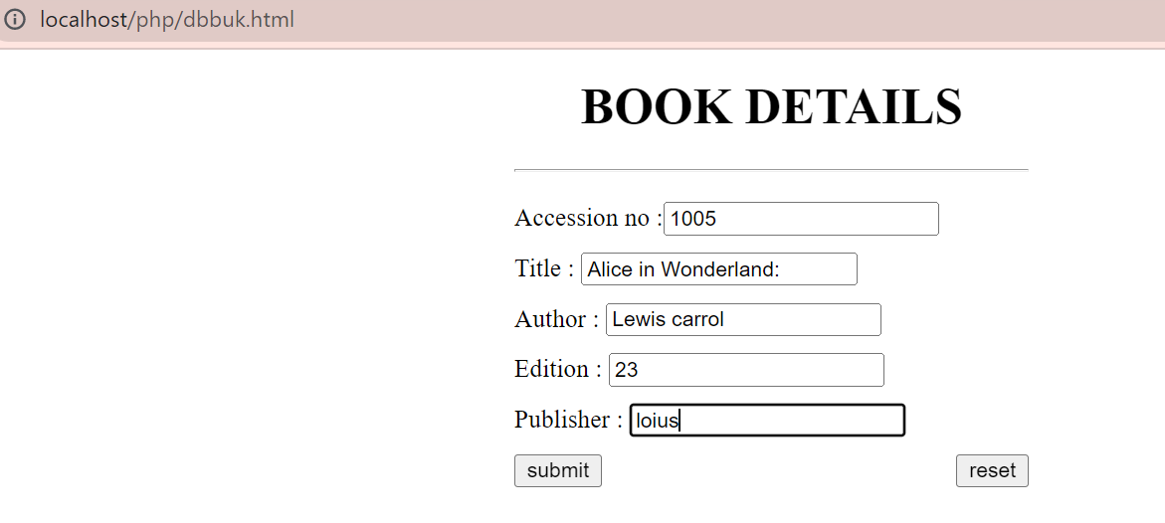







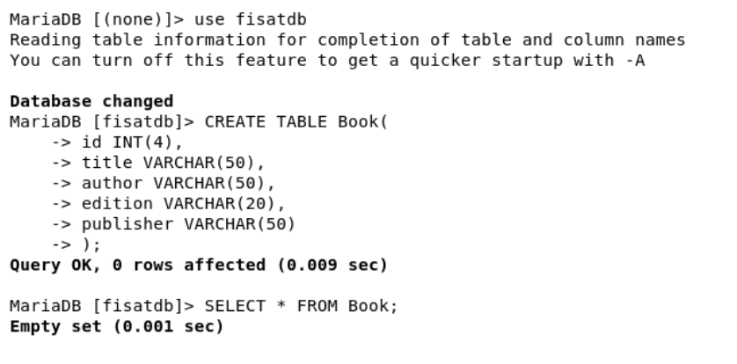

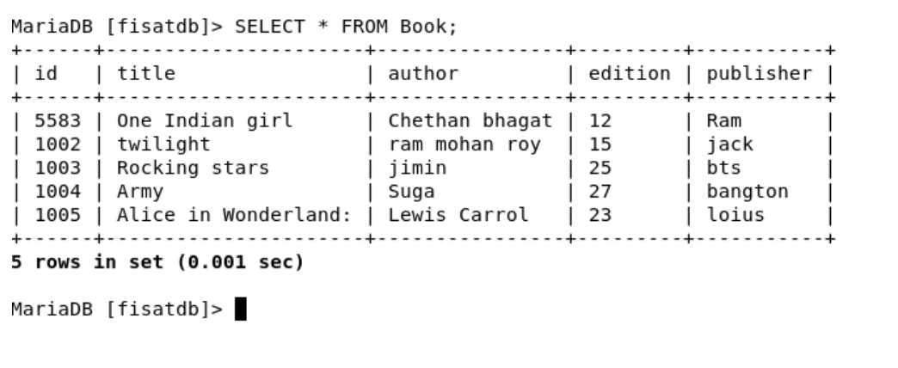

**EXPIREMENT 15**

**AIM**

Using PHP and MySQL, develop a program to collect airline details and display all the airlines between a particular source and destination.

**PROGRAM CODE**

**Airlineinfo.html**

<html>

<head>

<title>airline</title>

</head>

<body align="center"><u>AIRLINE INFORMATION SYSTEM</u><br>

<a href="addairlineinfo.html">Add AIRLINE DETAILS</a><br>

<a href="search1.html">Search AIRLINE DETAILS</a><br>

</body>

</html>

**Addairlineinfo.html**

<html>

<head>

<title>add airline</title></head>

<body>

<form name="frm1" action="addair.php" method="POST">

<center><b><u>Enter Airline Details</u></b><br>

AIRLINE ID:<input type="number" name="id"><br>

AIRLINE NAME:<input type="text" name="name"><br>

DEPARTURE FROM:<input type="text" name="depfrom"><br>

DEPARTURE TIME:<input type="number" name="deptime"><br>

AIRIVAL TIME:<input type="number" name="aritime"><br>

AIRIVAL PLACE:<input type="text" name="ariplace"><br>

<input type="submit" name="Submit">

<input type="reset" name=“Reset">

</form>

</body>

</html>

**Addair.php**

<?php

$id=$_POST['id'];

$name=$_POST['name'];

$depfrom=$_POST['depfrom'];

$deptime=$_POST['deptime'];

$airtime=$_POST['aritime'];

$airplace=$_POST['ariplace'];

$con=new mysqli("localhost","fisat","fisat","fisatdb");

if($con==false)

{

echo "Failed to connect";

}

else

{

echo "connected";

}

$sql="INSERT INTO airline VALUES($id,'$name','$depfrom',$deptime,$airtime,'$airplace')";

if($con->query($sql))

{

echo "<br>";

echo 'New row added';

}

else

{

echo "ERROR:could not execute query";

}

$con->close();

?>

**Search.html**

<html>

<head>

<title>search</title>

</head>

<body>

<form name="frm2" action="search1.php"method="POST">

<center>

<b><u>SEARCH AIRLINE</u></b><br>

NAME:<input type="text" name="txt2"><br>

DEPARTURE FROM:<input type="text" name="txt"><br>

ARIVAL PLACE:<input type="text" name="txt1"><br>

<input type="submit" name="Submit">

</center>

</form>

</body>

</html>

**Search1.php**

<?php

$depfrom=$_POST['txt'];

$ariplace=$_POST['txt1'];

$con=new mysqli("localhost","fisat","fisat","fisatdb");

if($con==false)

{

echo "Failed to connect";

}

else

{

echo "connected\n";

}

$sql="select * from airline where depfrom='$depfrom' and airplace='$ariplace' ";

if($result=$con->query($sql))

{

if (($result->num_rows)>0)

{

echo "<h2>AIRLINE INFO.</h2>";

echo "<table border='1'>";

echo "<tr>";

echo "<th width='100'>AIR_ID</th>";

echo "<th width='100'>AIR_NAME</th>";

echo "<th width='100'>DEPARTURE FROM</th>";

echo "<th width='100'>DEPARTURE TIME</th>";

echo "<th width='100'>AIR TIME</th>";

echo "<th width='100'>AIR PLACE</th>";

echo "</tr>";

while($row = $result->fetch_array())

{

echo "<tr>";

echo "<td>".$row[0]."</td>";

echo "<td>".$row[1]."</td>";

echo "<td>".$row[2]."</td>";

echo "<td>".$row[3]."</td>";

echo "<td>".$row[4]."</td>";

echo "<td>".$row[5]."</td>";

echo "</tr>";

}

echo "</table>";

$result->close();

}

else

{

echo "\nCould not found the airline";

}

}

else

{

echo "\nError:could not connect";

}

$con->close();

?>

**OUTPUT**

